Assignment 2 – Project Plan

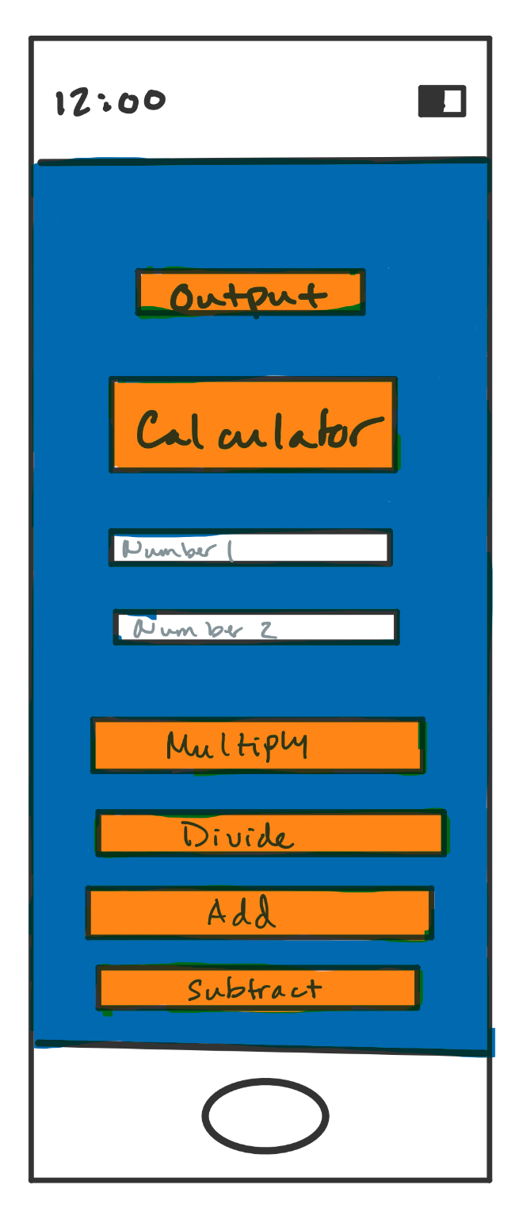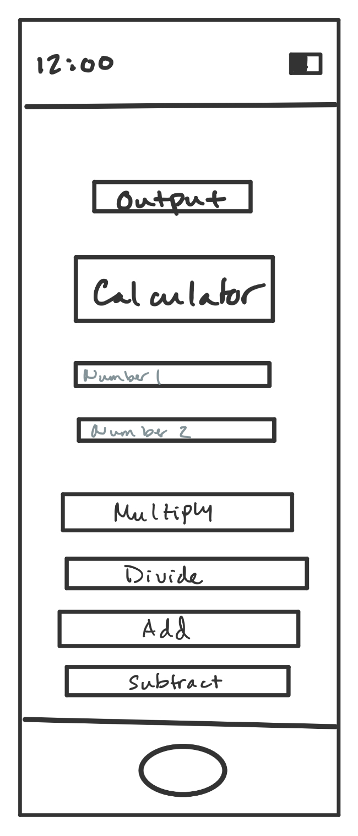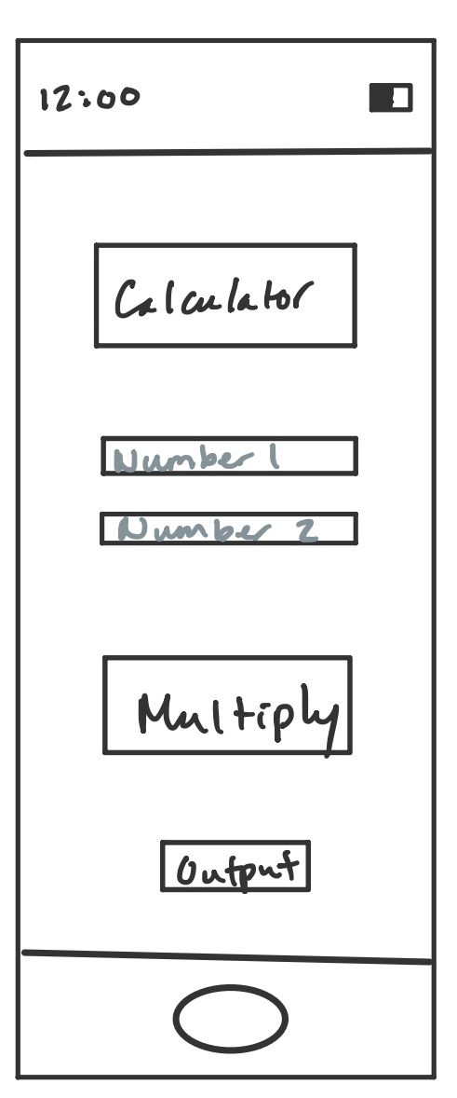

1. There are several calculator apps that look like an actual calculator. These apps you usually have to press the number you want, then the function, then another number for the function to run. A way I can make that easier is by having two input numbers with a button to run the calculation you need. This limits error in pressing the wrong function or having to go back and rerun because of input error.
2. The general audience would be anyone needing a simple calculator. This would be students K-12 or adults using it for simple calculations.
3. The main feature is that you won’t need internet for it to run.
4. I would make this free to use since it’s simple and mainly used by students.